**Assignment -4**

|  |  |
| --- | --- |
| Assignment Date | 21 September 2022 |
| Student Name | M.Parthiban |
| Student Roll Number | 420619104026 |
| Maximum Marks | 2 Marks |
| Project | Job/skill recommender application |

**Question-1:**

1. **Create a Bucket in IBM object storage. Solution:**

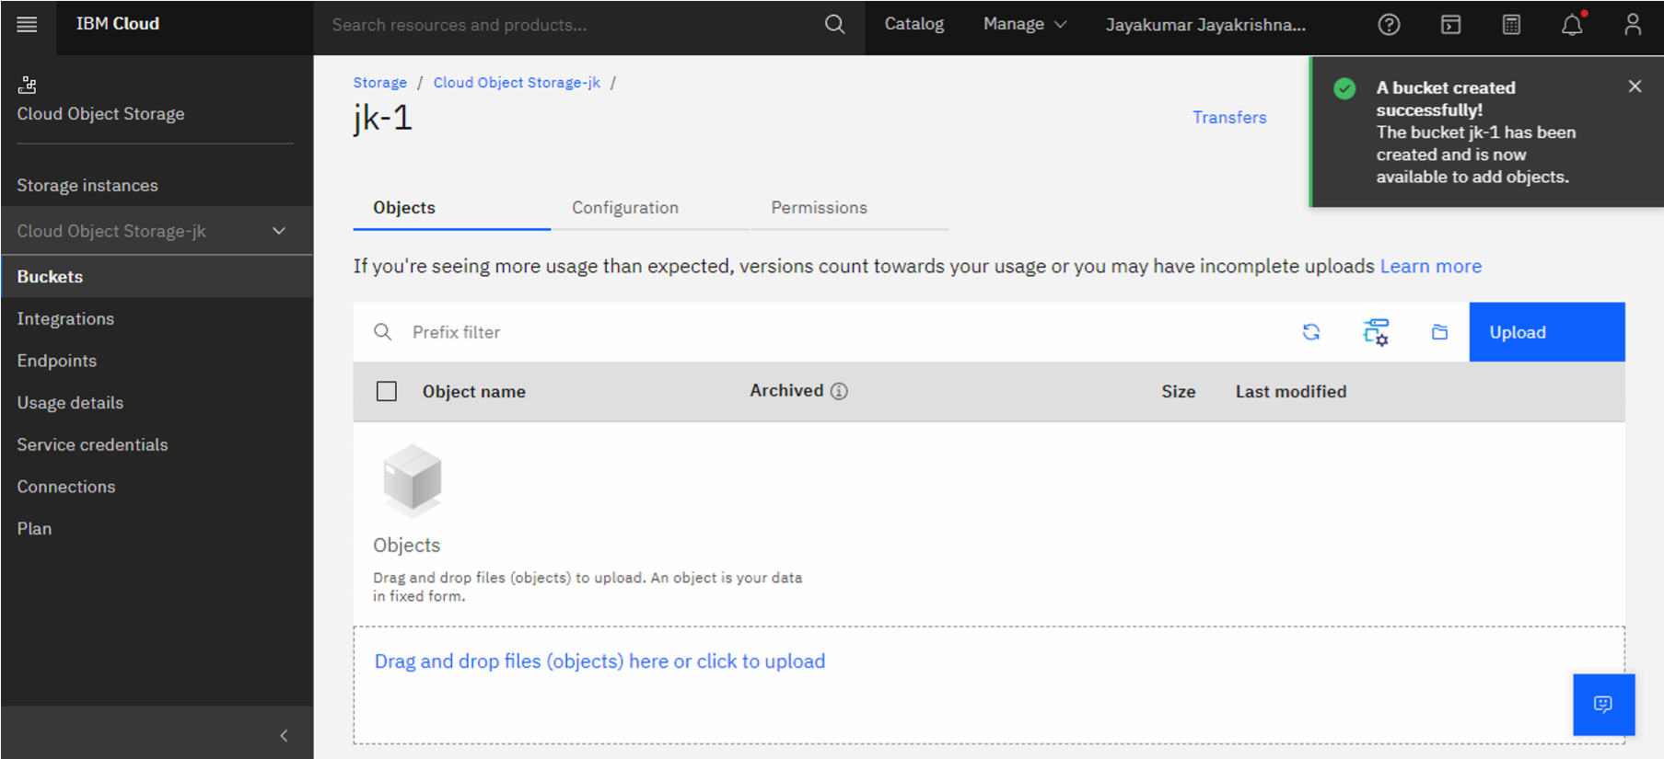

**Question-2:**

1. **Upload an 5 images to IBM object storage and make it public. Write html code displaying all the 5 images.**

# Solution:

# <a href="/">HOME</a>

# <br><hr>

# <h1>IBM Assignment</h1>

# <!doctype html>

# <html>

# <body>

# {% for row in files %}

# <div style="border: 1px solid #EFEFEF;margin:10px;">

# <h3>Filename : {{row}} </h3>

# <img src="https://jk-1.s3.jp-tok.cloud-object-storage.appdomain.cloud/{{row}}" width="150px"></td>

# </div>

# {% endfor %}

# </body>

# </html>

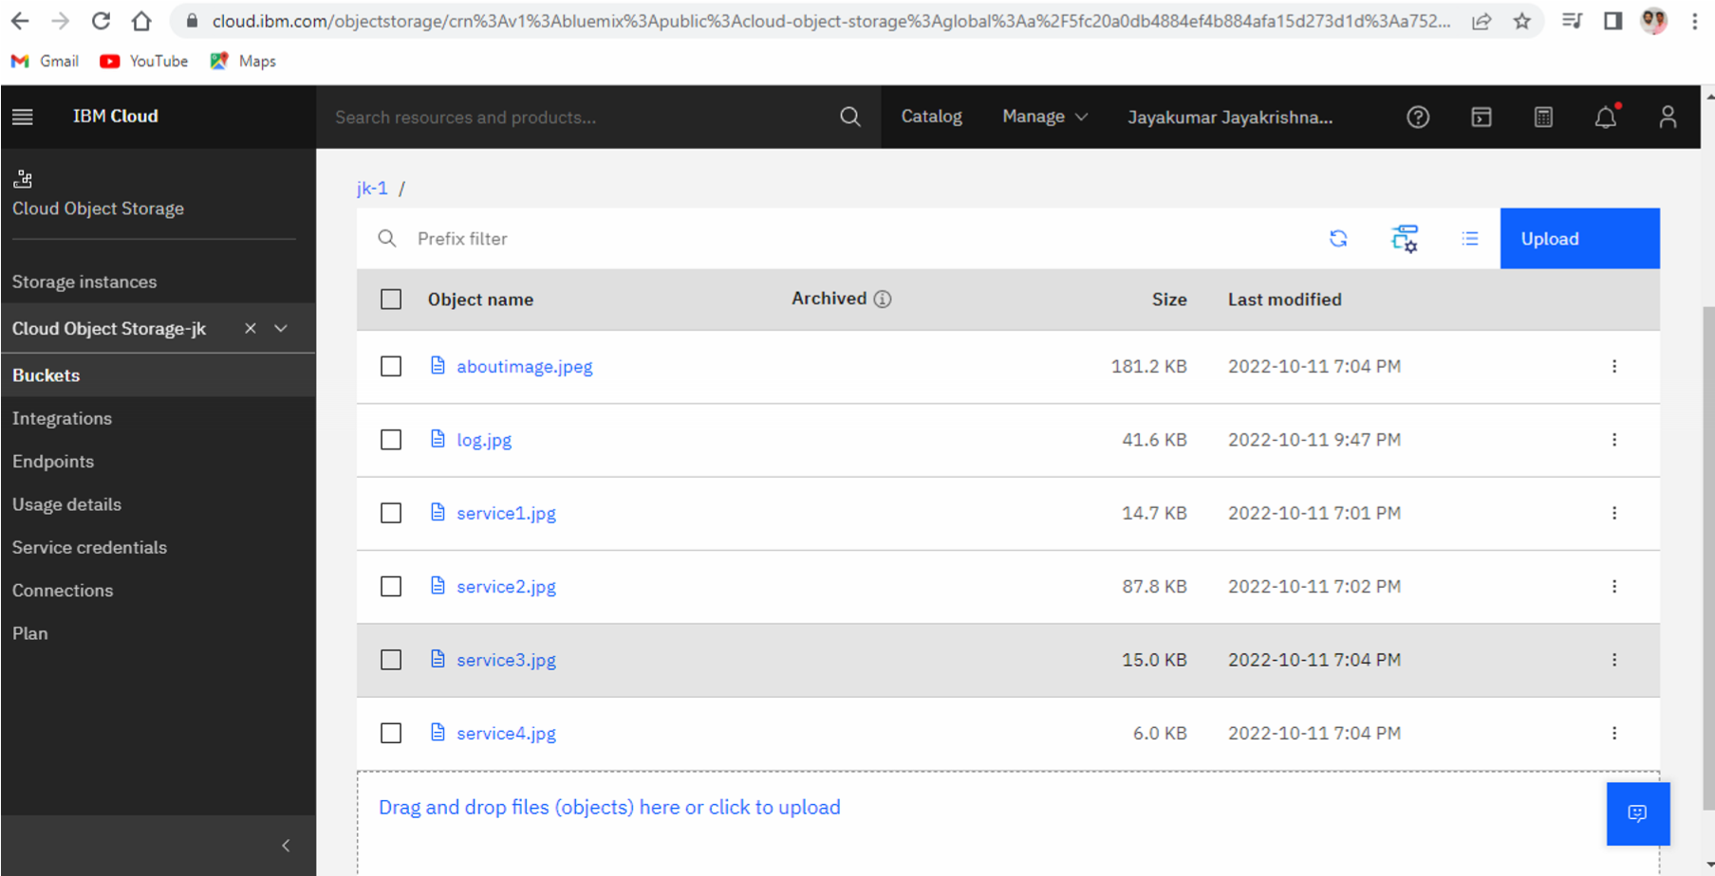

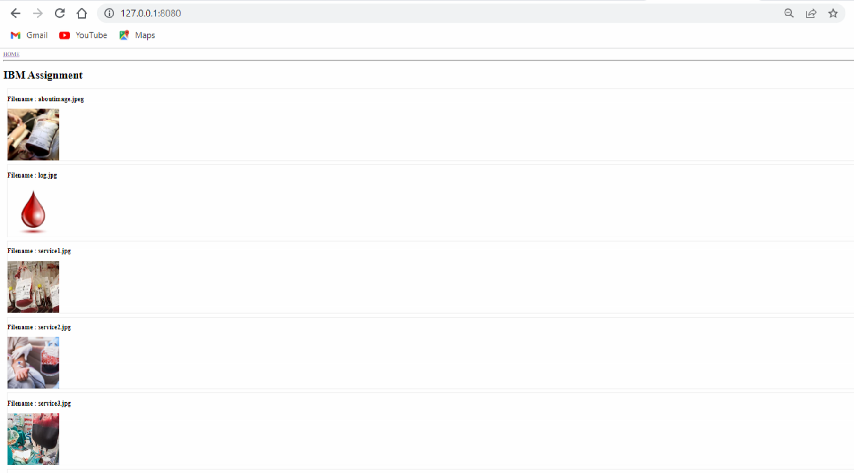

**Question-3:**

**3) Create a chatbot using IBM Watson assistant for hospital. Solution:**

# Link:

[**https://web-**](https://web-chat.global.assistant.watson.appdomain.cloud/preview.html?backgroundImageURL=https%3A%2F%2Feu-gb.assistant.watson.cloud.ibm.com%2Fpublic%2Fimages%2Fupx-c75821d2-37e1-47ca-bb94-37c7a34a1d34%3A%3A0466ba59-e813-4f0d-8d19-718b51451711&integrationID=28322410-7f61-456d-a3bf-bd638f4ea353&region=eu-gb&serviceInstanceID=c75821d2-37e1-47ca-bb94-37c7a34a1d34)

[**chat.global.assistant.watson.appdomain.cloud/preview.html?backgroundImageURL=https%3A%2 F%2Feu-gb.assistant.watson.cloud.ibm.com%2Fpublic%2Fimages%2Fupx-c75821d2-37e1-47cabb94-37c7a34a1d34%3A%3A0466ba59-e813-4f0d-8d19-718b51451711&integrationID=283224107f61-456d-a3bf-bd638f4ea353&region=eu-gb&serviceInstanceID=c75821d2-37e1-47ca-bb9437c7a34a1d34**](https://web-chat.global.assistant.watson.appdomain.cloud/preview.html?backgroundImageURL=https%3A%2F%2Feu-gb.assistant.watson.cloud.ibm.com%2Fpublic%2Fimages%2Fupx-c75821d2-37e1-47ca-bb94-37c7a34a1d34%3A%3A0466ba59-e813-4f0d-8d19-718b51451711&integrationID=28322410-7f61-456d-a3bf-bd638f4ea353&region=eu-gb&serviceInstanceID=c75821d2-37e1-47ca-bb94-37c7a34a1d34)

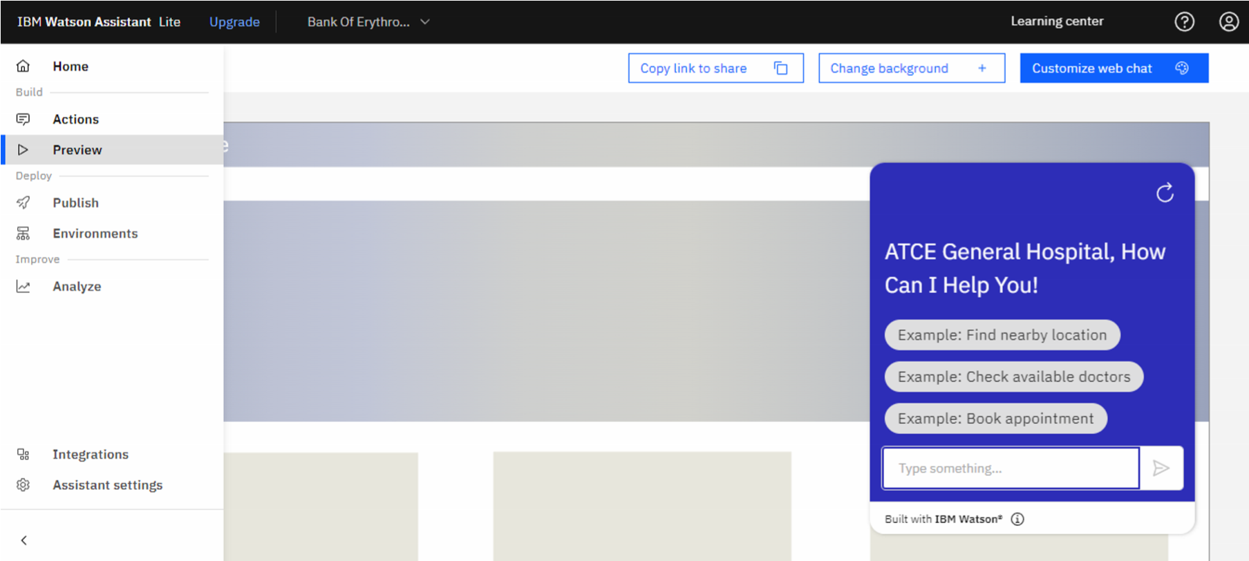

**Question-4:**

**4) Create Watson assistant service with 10 steps and use 3 conditions in it. Load that script in HTML page. Solution:**

# HTML Code:

<!DOCTYPE html>

<html lang="en">

<head>

<meta charset="UTF-8">

<meta http-equiv="X-UA-Compatible" content="IE=edge">

<meta name="viewport" content="width=device-width, initial-scale=1.0">

<title>JOBPORTAL | HOME</title>

<meta charset="UTF-8">

<!-- favicon -->

<!-- <link rel="shortcut icon" href="/assets/img/favicon.ico" type="image/x-icon"> -->

<!-- <link rel="icon" href="/assets/img/favicon.ico" type="image/xicon"> -->

<link rel="icon" type="image/png" sizes="16x16" href="/assets/img/favicon-32x32.png">

<!-- bootstrap css cdn -->

<link rel="stylesheet" href="https://stackpath.bootstrapcdn.com/bootstrap/4.5.2/css/bootstrap.min.css

" integrity="sha384-

JcKb8q3iqJ61gNV9KGb8thSsNjpSL0n8PARn9HuZOnIxN0hoP+VmmDGMN5t9UJ0Z" crossorigin="anonymous"> <link rel="stylesheet" href="https://cdnjs.cloudflare.com/ajax/libs/font-awesome/4.7.0/css/fontawesome.css">

<!-- css stylesheet -->

<link rel="stylesheet" href="css/style.css">

<!-- font styles cdn -->

<link rel="preconnect" href="https://fonts.gstatic.com">

<link href="https://fonts.googleapis.com/css2?family=Alegreya&display=swap" rel="stylesheet"> <link href="https://fonts.googleapis.com/css2?family=Alegreya:wght@600&display=swap" rel="stylesheet">

</head>

<body>

<!-- bootstrap navbar -->

<nav class="navbar sticky-top navbar-expand-lg navbar-dark">

<div class="container-fluid">

<a class="main-logo-img mt-3" href="#"><img src="/static/img/smartinternz.png" alt="sheep-logo" height="50px" width="180px">

<!-- <a class="navbar-brand" href="index.html">JobPortal</a> ->

</a>

<div class="row donate-sponsor">

<a type="button" class="btn btn-success mr-1" id="donate" href="login">LOGIN</a>

<a type="button" class="btn btn-warning mr-1" id="sponsor" href="register">REGISTER</a>

<a type="button" class="btn btn-primary mr-1" id="sponsor" href="contact.html">CONTACT US</a>

</div>

</div>

</nav>

<!-- navbar ends -->

<!-- what we focus on -->

<section class="our-focus">

<div class="container">

<h2 class="text-center mt-3">Aboutus</h2>

<div class="row ml-3 mt-3">

<div class="col-lg-3 mr-5" id="focus-first">

<div class="card" style="width: 19rem;">

<!-- <img src="assets/img/home kids.jpg" class="card-imgtop" alt="..."> -->

<div class="card-body">

<h5 class="card-title">Mission</h5>

<p class="card-text">JOBPORTAL is an edTech organization with a vision to bridge the gap between academia & industry. Our outcome-based experiential learning programs on emerging technologies (Internet of Things, Machine Learning, Data Science, Artificial Intelligence, Robotics) are building skilled entry - level engineers, for the corporate world. .

</p>

</div>

</div>

</div>

<div class="col-lg-3 mr-5" id="focus-second">

<div class="card" style="width: 20rem;">

<!-- <img src="assets/img/friendship day.JPG" class="cardimg-top" alt="..."> -->

<div class="card-body">

<h5 class="card-title">Vission</h5>

<p class="card-text">Our main objective is to bridge the existing gaps between prevailing industry standards and what the academics offer to the graduates while passing out of university. Jobportal offers suitable skill deployment and training to the young talent before on boarding their first job.

Our skill development programs are designed considering the present expectations in the industry. </p>

</div>

</div>

</div>

<div class="col-lg-3 ml-5" id="focus-third">

<div class="card" style="width: 20rem;">

<!-- <img src="assets/img/health camp.jpg" class="cardimg-top" alt="..."> -->

<div class="card-body">

<h5 class="card-title">Objective</h5>

<p class="card-text">Well directed career guidance programs for educational institutions

Appropriate certification courses that suit the industry need

Train the trainers; expanded awareness about the current industry standards

Liaise with corporates to offer niche internships

Establish technology development centers in colleges

Specialised incubation centers in collaboration with corporates</p>

</div>

</div>

</div>

</div>

</div>

</section>

<!-- focus section ends -->

<!-- footer starts -->

<!-- Site footer -->

<footer class="site-footer">

<div class="container mt-5">

<div class="row">

<div class="col-sm-12 col-md-6">

<h3>JobPortal</h3>

<p class="text-justify">Lorem ipsum dolor sit amet consectetur adipisicing elit.

Voluptatum quis, reiciendis id magni magnam, accusamus nobis in, temporibus molestias ab placeat rerum aperiam illum perspiciatis ducimus non! Fugiat, odit ducimus.</p>

</div>

<div class="col-xs-6 col-md-3">

<h4>Get in Touch</h4>

<ul class="footer-links">

<li><a href="mailto:test@gmail.com">jobportal@gmail.com</a></li> <li><a href="">+91 900000000</a></li>

</ul>

</div>

</div> <hr>

</div>

</div>

<div> <script>

window.watsonAssistantChatOptions = {

integrationID: "7416cfb2-3c28-4931-a308-e98f7297a756", //

The ID of this integration.

region: "au-syd", // The region your integration is hosted in.

serviceInstanceID: "3d7af5c0-3e62-487b-bcc8-ca0f1d31ed7e",

// The ID of your service instance.

onLoad: function(instance) { instance.render(); }

}; setTimeout(function(){ const t=document.createElement('script');

t.src="https://web-

chat.global.assistant.watson.appdomain.cloud/versions/" +

(window.watsonAssistantChatOptions.clientVersion || 'latest') +

"/WatsonAssistantChatEntry.js"; document.head.appendChild(t);

});

</script>

</div>

</footer>

</body>

</html>

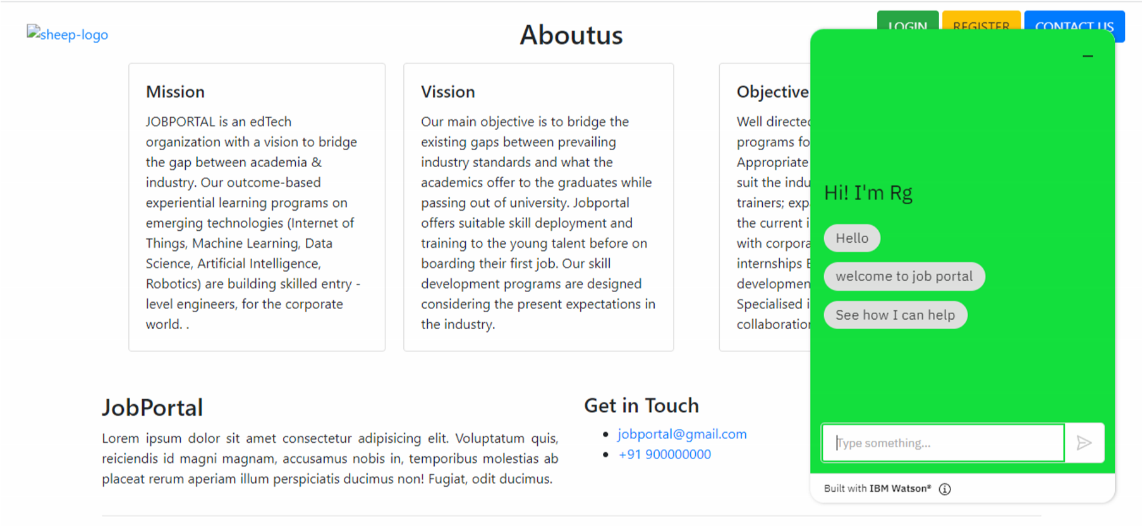

# Embed code:

<script>

window.watsonAssistantChatOptions = {

integrationID: "7416cfb2-3c28-4931-a308-e98f7297a756", // The ID of this integration. region: "au-syd", // The region your integration is hosted in.

serviceInstanceID: "3d7af5c0-3e62-487b-bcc8-ca0f1d31ed7e", // The ID of your service instance.

onLoad: function(instance) { instance.render(); }

};

setTimeout(function(){

const t=document.createElement('script'); t.src="https://web-

chat.global.assistant.watson.appdomain.cloud/versions/" + (window.watsonAssistantChatOptions.clientVersion || 'latest') +

"/WatsonAssistantChatEntry.js"; document.head.appendChild(t);

});

</script>